Graphical abstract for the paper:

Conspiracy theories are central to the complex system of predictors of Italian vaccine hesitancy

Abstract
Vaccines against COVID-19 are available worldwide, but their uptake is hampered by vaccine hesitancy. The determinants of this skepticism received copious empirical attention. Researchers have identified more than 50 predictors of this behavior. However, these determinants have been identified through a reductionist approach, studying the pairwise interactions hesitancy has with other variables. Moreover, the abundance of these factors can hinder the design of effective interventions. To overcome these limitations, we adopt a complex systems approach to study vaccine hesitancy in Italy, where hesitation rates are among the highest in the world. We adopt a mixed graphical model that renders survey variables as nodes of a network whose weighted, undirected edges are estimated from real data and are indicative of their linear influences. Results reveal that endorsing conspiracy theories plays a fundamental role in this system, as this variable is tied to almost 70% of the other predictors. Finally, we isolate a restricted list of empirical predictors that can help policymakers willing to implement intervention strategies.

Keywords: Broad Attitude Network, Complex System, Vaccine Hesitancy, Italy

Figure:
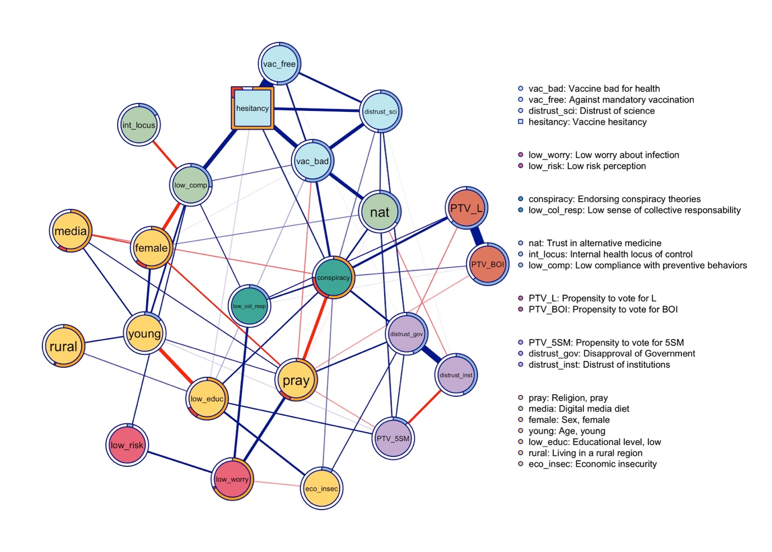

Please, use the colored version of the figure.

